*****Instituto Politécnico Nacional***

***Escuela Superior de Cómputo***

*Arquitectura de Computadoras*

***Practica 7: Memoria de Datos***

***Nombre:*** *Sampayo Hernández Mauro*

***Grupo:*** *3CV8*

***Profesor:*** *Nayeli Vega García*

***Fecha de entrega:*** *9 de abril del 2020*

**Código de implementación:**

library IEEE;

use IEEE.STD_LOGIC_1164.ALL;

use ieee.std_logic_arith.all;

use ieee.std_logic_unsigned.all;

entity MemoriaDatos is

generic (d : integer := 16);

Port (dataIn: in STD_LOGIC_VECTOR (d-1 downto 0);

add : in STD_LOGIC_VECTOR (d-1 downto 0);

clk, WD : in STD_LOGIC;

dataOut : out STD_LOGIC_VECTOR (d-1 downto 0));

end MemoriaDatos;

architecture Behavioral of MemoriaDatos is

type banco is array (0 to (2**d)-1) of std_logic_vector(d-1 downto 0);

signal memData : banco;--memoria del banco de memoria

begin

process(clk)

begin

if (clk' event and clk = '1') then

if (WD = '1') then

memData(conv_integer(add)) <= dataIn;

end if;

end if;

end process;

dataOut <= memData(conv_integer(add));

end Behavioral;

**Código de simulación:**

library IEEE;

LIBRARY STD;

USE STD.TEXTIO.ALL;

USE IEEE.std_logic_TEXTIO.ALL; --PERMITE USAR STD_LOGIC

USE IEEE.std_logic_1164.ALL;

USE IEEE.std_logic_UNSIGNED.ALL;

USE IEEE.std_logic_ARITH.ALL;

entity MemoriaDatos_tb is

end MemoriaDatos_tb;

architecture Behavioral of MemoriaDatos_tb is

component MemoriaDatos is

Port (dataIn: in STD_LOGIC_VECTOR (15 downto 0);

add : in STD_LOGIC_VECTOR (15 downto 0);

clk, WD : in STD_LOGIC;

dataOut : out STD_LOGIC_VECTOR (15 downto 0));

end component;

--Inputs

signal dataIn : std_logic_vector(15 downto 0) := (others => '0');

signal add : std_logic_vector(15 downto 0) := (others => '0');

signal clk : std_logic := '0';

signal WD : std_logic := '0';

--Outputs

signal dataOut : std_logic_vector(15 downto 0);

-- Clock period definitions

constant clk_period : time := 10 ns;

begin

uut: MemoriaDatos Port Map(

dataIn => dataIn,

add => add,

clk => clk,

wd => wd,

dataOut => dataOut);

-- Clock process definitions

clk_process :process

begin

clk <= '0';

wait for clk_period/2;

clk <= '1';

wait for clk_period/2;

end process;

-- Stimulus process

stim_proc: process

file ARCH_RES : TEXT;--Archivo de resultados

variable LINEA_RES : line;--Linea de resultado

file ARCH_VEC : TEXT;--Archivo de vectores

variable LINEA_VEC : line;--Linea de vectores

--Variables

variable V_DATAIN, V_ADD, V_DATAOUT: STD_LOGIC_VECTOR(15 DOWNTO 0);

variable V_WD: STD_LOGIC;

--Cadena

variable CADENA : STRING(1 TO 4);

begin

file_open(ARCH_VEC, "VECTORES.txt", READ_MODE);

file_open(ARCH_RES, "RESULTADO.txt", WRITE_MODE);

--Impresión de Encabezado

CADENA := " ADD";

write(LINEA_RES, CADENA, right, CADENA'LENGTH+1); --"ADD"

CADENA := " DIN";

write(LINEA_RES, CADENA, right, CADENA'LENGTH+1); --"DATAIN"

CADENA := " WD";

write(LINEA_RES, CADENA, right, CADENA'LENGTH+1); --"WRITE DATA"

CADENA := "DOUT";

write(LINEA_RES, CADENA, right, CADENA'LENGTH+1); --"DATAOUT"

writeline(ARCH_RES,LINEA_RES);--Escribe la linea en el archivo

--Impresión de Resultados

wait for 100 ns;

for i in 0 to 11 loop

--lectura de VECTORES.TXT--

readline(ARCH_VEC,LINEA_VEC);--Lee una linea completa

Hread(LINEA_VEC, V_ADD);

ADD <= V_ADD;

Hread(LINEA_VEC, V_DATAIN);

DATAIN <= V_DATAIN;

read(LINEA_VEC, V_WD);

WD <= V_WD;

wait until RISING_EDGE(CLK);--Espera al Flanco de Subida

V_DATAOUT := DATAOUT;--Asignación de salidas

--Escritura de Resultados

Hwrite(LINEA_RES, V_ADD, right, 5);

Hwrite(LINEA_RES, V_DATAIN, right, 5);

write(LINEA_RES, V_WD, right, 5);

Hwrite(LINEA_RES, V_DATAOUT, right, 5);

writeline(ARCH_RES,LINEA_RES);--Escribe la linea en el archivo

end loop;

file_close(ARCH_VEC);--Cierra el archivo

file_close(ARCH_RES);--Cierra el archivo

wait;

end process;--Stimulus process

end Behavioral;

**Diagrama RTL:**

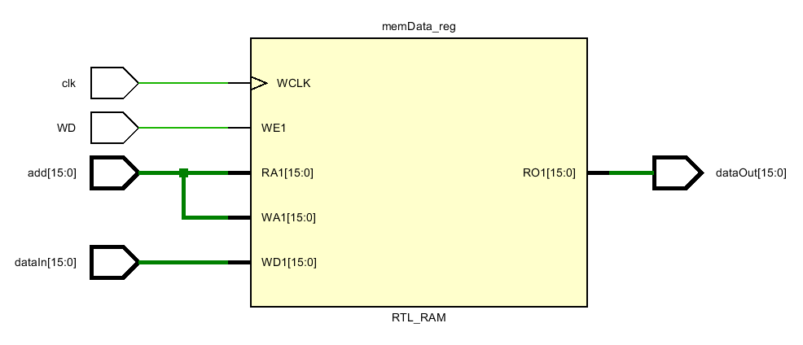

**Simulación:**

